Help for GreenStep Cities to Manage the Emerald Ash Borer Infestation
Michael Orange, orange_michael@msn.com, 952-905-1448
March 2, 2019

Hello everyone:

The Director of the GreenStep Cities Program, Phil Muessig, asked me to connect with each of you because you expressed an interest in getting help in managing the Emerald Ash Borer (EAB) infestation.

I am a member of the Minnesota Pollution Control Agency’s Retired Environmental Technical Assistance Program (RETAP) and I help Phil and the GreenStep Cities (GSC) Program with this issue. Last year, I made a presentation about EAB management plans titled “Save the best, replace the rest” as a part of the GSC workshop on invasive species. You can see the presentation here:
http://www.betterenergy.org/blog/greenstep-cities-march-workshop/

I have attached the Minnesota Model EAB Management Plan that Jeff Hafner and I developed to help cities develop their plans. There are few points I’d like to stress:
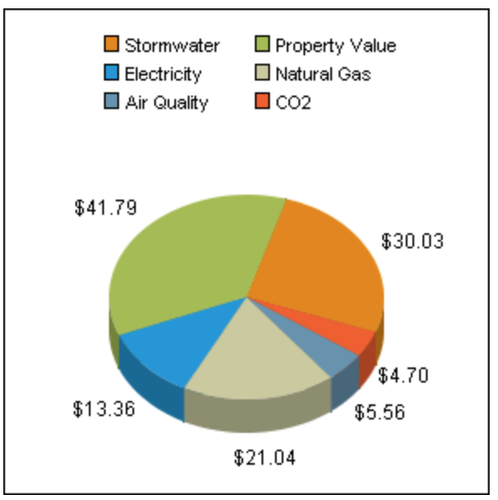
- Save the best, replace the rest: This slogan summarizes the best strategy for the environment and for the city budget. On average, you can treat a mature, healthy ash tree for more than 20 years for the cost of removing and replacing it, plus preserve 3-4 times the tree benefits.
- Tree value: According to the US Forest Service’s National Tree Benefit Calculator, a healthy ash tree (12-inch diameter) provides $116 worth of benefits each year.
- Public tree inventory: An essential component is to know your urban forest. At minimum, you should inventory the location, condition, and size of ash trees located on public property. Less important are ash trees in wooded areas of public parks but they can play an important role too (as described in the model plan).
- Tree classification: Next you need to classify these public ash trees into at least two categories: High-quality trees worth saving (large, healthy trees that are located where their benefits are most valuable), and low-quality trees that should be removed (smaller, unhealthy trees where the elimination of their benefits will have less of effect).
- Timing: EAB will kill every unprotected tree within 3-4 years of being infested and the infestation will kill virtually all unprotected ash trees in an area within 10-12 years in most cases.
- Treatment: The recommended pesticide to inoculate high-quality ash trees against the infestation is emamectin benzoate (not a neonicotinoid). Scientists have concluded that the potential risks of saving the best ash trees using this systemic pesticide are minor and are far outweighed by the environmental effects of instead losing these trees.
- Planning: Once you have an inventory, you can use economic planning tools to develop an implementation plan. Purdue University developed a free, on-line cost calculator that enables you to enter your inventory and cost data and compare the costs of three different treatment and removal strategies: https://int.entm.purdue.edu/ext/treecomputer/ Unfortunately, the calculator does not let you compare costs to the resultant benefits. However, there are companies that will help you compare both the costs and the benefits of a variety of different strategies.
- Herd immunity: To fight a human epidemic, a critical percentage of the population needs to be inoculated—not everyone. Similarly, with the EAB infestation, scientists have concluded there is a “herd immunity” effect with a critical percentage of treatments. You can help preserve your urban forest, both public and private trees, by inoculating as many high-quality city trees as possible.

I am happy to discuss these issues with you but RETAP does not have the budget to actually develop an EAB management plan for your city.

Keep in mind that as long as you have ash trees, EAB will eventually kill every unprotected tree. Management options decrease as the infestation gets closer.

The MN DNR provides a map with the current spread of the infestation:
https://mnag.maps.arcgis.com/apps/webappviewer/index.html?id=63ebb977e2924d27b9ef0787ecedf6e9

Remember, save the best and replace the rest.

Michael Orange

