**Greening Lawn Irrigation:**

**A toolkit for Cities seeking to engage homeowners in water conservation through improved lawn care practices**



**2015**

**2016**

This project was supported by the Resilient Communities Project (RCP), a program at the University of Minnesota that convenes the wide-ranging expertise of U of M faculty and students to address strategic local projects that advance community resilience and sustainability. RCP is a program of the Center for Urban and Regional Affairs (CURA) and the Institute on the Environment.

This work is licensed under the Creative Commons Attribution-NonCommercial 3.0 Unported License. To view a copy of this license, visit <http://creativecommons.org/licenses/by-nc/3.0/> or send a

letter to Creative Commons, 444 Castro Street, Suite 900, Mountain View, California, 94041, USA. Any reproduction, distribution, or derivative use of this work under this license must be accompanied by the following attribution: “Produced by the Resilient Communities Project at the University of Minnesota, 2015. Reproduced under a Creative Commons Attribution-NonCommercial 3.0 Unported License.”

This publication may be available in alternate formats upon request.

**Resilient Communities Project**

University of Minnesota 330 HHHSPA

301—19th Avenue South Minneapolis, Minnesota 55455

Phone: (612) 625-7501

E-mail: [rcp@umn.edu](mailto:rcp@umn.edu)

Web site: [http://www.rcp.umn.edu](http://www.rcp.umn.edu/)

*The University of Minnesota is committed to the policy that all persons shall have equal access to its programs, facilities, and employment without regard to race, color, creed, religion, national origin, sex, age, marital status, disability, public assistance status, veteran status, or sexual orientation.*

**Acknowledgements**

This document has been prepared by the University of Minnesota’s Resilient Communities Project for the Greenstep Cities Program. The materials contained within this guide have been adapted from student work completed in partnership with the Resilient Communities Project. The Resilient Communities Project would like to thank the following student contributors including Ashley Alexander, Renee Bergstro, Paul Rinas, Enes Gokce, Tunde Ogungbesan, Cynthia Secord, Pamela Streed and Dawsood Sultani, Abdi Hussein, Alex Kim, Kelly McCormick, and Ryan McGlynn as well as Dr. Catherine Twohig (Instructor, OLPD 5204) and Dr. Matt Simcik (Instructor, PUBH 6132). We would also like to thank Carmelita Nelson of the Minnesota Department of Natural Resources who provided both guidance and materials.





Table of Contents

Executive Summary and Toolkit Content 7

Water Conservation in Minnesota 8

Reaching a Target Audience: Talking to Homeowners about Water Conservation 11

Messaging 11

Platforms for message delivery 12

Additional Promotion Tools 13

Connecting with Community Members One-on-One 14

Over the phone 14

In-Person Outreach 14

Best Lawn Watering Practices- Talking Points 15

Online Resources 18

Examples of City Water Conservation Webpages 18

Reaching Homeowners through Social Media 19

Sample Facebook Post 20

Sample Facebook quiz 21

Sample YouTube Videos 22

Sample Website Content 23

Brochures, Posters and Other Printed Materials 24

Sample Flier: Water You Doing to Conserve? 25

Sample Letter to Homeowners 26

Sample Brochures 29

Sample Articles about Water Conservation 32

Conducting Water Conservation Presentations, Seminars and Events 33

Attending Pre-Established Community Events 33

Planning an Event 34

Examples of Water Conservation Events in Minnesota 35

Water Conservation Education Displays 37

Sample PowerPoint Presentation 38

Sample Lesson Plans for In-Person seminar: 45

Evaluating Homeowner Outreach 51

Additional Resources 53

Water Resource Subject Matter Experts 55

Work Cited 56

# Executive Summary and Toolkit Content

Water conservation is becoming an increasingly urgent concern for communities throughout Minnesota. The land of 10,000 lakes is experiencing increasingly urgent threats to groundwater supply due to over-use. Natural replenishment of aquifers may not keep up with the rate of use seen in Minnesota. The loss of groundwater reserves can result in increased pumping costs, and impact local lakes, streams and wetlands. Local municipalities can help to address this problem by engaging local homeowners in conversations to educate them about water conservation and motivate them to make simple changes in their homes to conserve this precious resource.

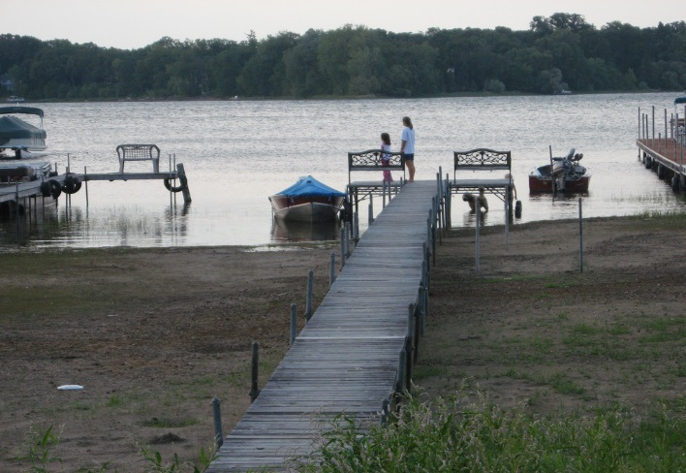

Figure 1: Water Level Reduction at White Bear Lake

According to the Freshwater Society, as much as 25% of the lost water from White Bear Lake, Minnesota was believed to be caused by over-pumping of water from aquifers to supply nearby residential areas. Photo Credit: [cn-brown](https://www.flickr.com/photos/cn-brown/1228274692/)

This toolkit is meant to serve as a guide for cities throughout Minnesota interested in engaging local homeowners about water conservation. This guide document focuses upon generating awareness and motivating Minnesota city residents to change behaviors around lawn irrigation practices. According to the Freshwater Society[1], many customers of suburban water systems in Minnesota primarily draw from groundwater resources for lawn care. In Minnesota, lawn over-irrigation during the hot, humid summer months is a major contributor to residential water over-use in the state. Correcting the problem of lawn over-irrigation seen in Minnesota could help to conserve and improve the quality of local groundwater resources, save homeowners money, and even improve the health of lawns that are currently being overwatered.

This tool outlines recommendations and sample materials for an outreach program focused on generating awareness and motivating city residents to change behaviors around lawn irrigation practices to conserve water and save money. This guide provides a brief overview of the issue of water conservation in Minnesota, reviews the messaging and types of outreach platforms that cities can use to engage homeowners about lawn irrigation practices, and provides samples of materials that communities can adapt and use for outreach. The tool also provides examples of efforts that have already been undertaken by communities throughout Minnesota to address residential lawn irrigation and water conservation. By utilizing a variety of the outreach platforms outlined in this guide, local cities will be able to better engage homeowners about water conservation and lawn care.

# Water Conservation in Minnesota

While Minnesotans historically have viewed water as being plentiful, the land of 10,000 lakes is experiencing more and more threats to groundwater supply. Groundwater is naturally found in undergrown reservoirs known as aquifers and is replenished by water filtering into the soil through infiltration. According to the Minnesota Department of Natural Resources (DNR), groundwater is currently the source of drinking water to 75% of Minnesotans and an increasing number of people and businesses are relying on groundwater as a primary source of drinking water every year.[2]

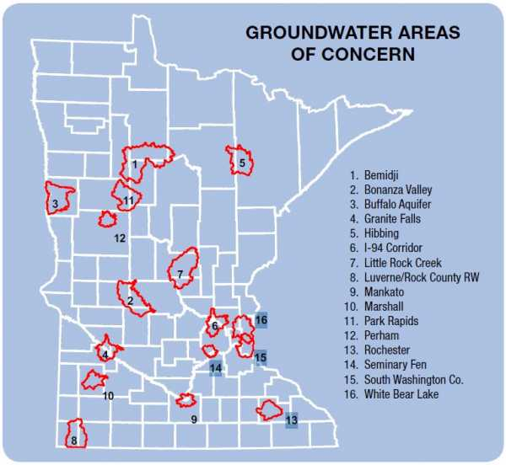

Figure 2: Groundwater Areas of Concern in Minnesota. Source: MnDNR, 2012. For more information read: <http://freshwater.org/wp-content/uploads/2013/04/Updated-MNs-Groundwater-Paper-lo-res.pdf>

In some areas of Minnesota the demand for water can exceed the supply that is readily available and naturally occurring recharge of aquifers cannot keep up with the current rate of water use.[3] In these areas the lack of alternate aquifers combined with the high demand for water resources can result in groundwater decline.[4] In its 2013 report, Fresh Water Society identified groundwater areas of concern in Minnesota (Figure 2). Groundwater issues in Minnesota are most common during the hot summer months when more water is being pumped from aquifers for lawn care and irrigation.

High volume pumping does not allow for groundwater to recharge the aquifer and can lead to drying wells, increasing pumping costs and the degradation of aquatic ecosystems. Three quarters of Minnesotans rely upon wells for drinking water.[5] Groundwater decline can cause local wells to go dry[6] and as groundwater becomes scarcer, pumping costs can increase. Over pumping can even impact surface water features, such as springs, that rely on a constant flow of groundwater. Groundwater depletion can alter the flow of water, decrease water levels and deteriorate water quality in local streams, lakes, springs, and wetlands. This can have adverse effects on the habitat, plants, and wildlife.[7] [8]

According to the Freshwater Society, municipal water systems use the largest proportion of groundwater in Minnesota. While the Minnesota DNR recommended usage is 75 gallons per day per capita, many communities throughout the state surpass this recommended level. During summer months, a municipal water supply system may pump water at a rate that is three times the amount pumped during the winter. This increase in water use is primarily due to summer landscaping and lawn watering practices. Lawn irrigation makes up 59% of home water use, more than indoor use such as showers, toilets, and kitchen usage combined. The EPA’s WaterSense program estimates that nationwide, landscape irrigation accounts for 1/3 of all residential water use and totals to about 9 billion gallons every day.[9]

**Lawn Irrigation:** Lawn irrigation is a major contributor to groundwater use in urban and suburban Minnesota where customers primarily rely upon groundwater for watering lawns.[10] Many residential lawns in the state are also being overwatered. Overwatering can have adverse impacts on the lawn itself as well as nearby aquatic ecosystems. Besides negatively affecting local groundwater supplies, overwatered lawns promote shallow roots and can become waterlogged creating an advantageous environment for disease, moss, and fungus growth ultimately negatively affecting the health of the lawn.[11] Overwatering can also remove excess nutrients, including fertilizers, from the lawn which can runoff into lakes and streams.[12] Excess nutrients in surrounding bodies of water contribute to eutrophication,[13] algae blooms, and aquatic wildlife to die off. Besides irreversible damage to local water bodies, this can reduce the recreational value of local lakes that were once used for swimming, fishing, and tourism.[14] To make matters worse, it is estimated that up to 50% of water used for irrigation can be wasted due to evaporation, wind, or runoff due to inefficient irrigation methods.[15] This results in wasted water and money.

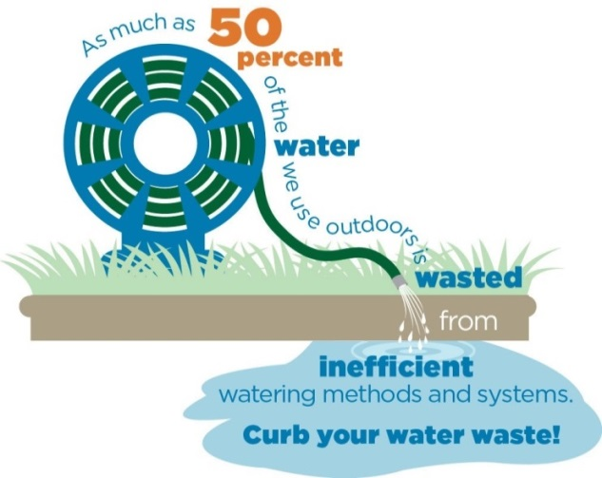

Source: EPA WaterSense Program

**Conservation Irrigation:** Many of the steps that homeowners can take to conserve water during lawn irrigation have no, or low, cost. By simply correcting the inefficiencies that lead to over-irrigation homeowners can save money, improve the quality of their lawns, prevent groundwater depletion and protect the aquatic ecosystems that make Minnesota proud to be known as “The Land of 10,000 Lakes.” Some of the simple steps that are recommended include: adjusting the timing of lawn watering, testing soil moisture to check if it needs to be watered or planting native species that require less water. Homeowners can also invest in high-efficiency spray nozzles and check their irrigation systems for leaky pipes, valves or broken spray nozzles that need repairs.

Homeowners can also invest in smart irrigation technologies. For example, smart controllers are available to consumers to help manage water more effectively. These controllers are designed to use data about your overall climate, weather, and the specific layout of your lawn to manage water usage more efficiently. Rachio[16], just one of the controllers available on the market, tells you when it’s raining so you can turn off the sprinklers. Using smart phone technology, these controllers can be accessed and controlled from anywhere. The controllers use WIFI, evaporation information, rain sensors, soil sensors, zone information, and most importantly, give users more control over the irrigation process. Using smart controllers based on weather data and evaporation could cut down on half of the waste, saving both water and money. Using a smart irrigation system like IrriGreen[17] could save money and pay for itself over the course of 3-4 years.

**Why Cities should be in the water conservation business**:

It is possible to both achieve our water conservation goals and support the quality of life we desire. A tremendous supply of information and technical tools are already available to help homeowners learn to better conserve and use their water supplies. However, beyond technical and scientific advances water conservation requires individuals to recognize wasteful water practices and commit to changing their behavior. Making these changes in our own habits is the largest obstacle that prevents us from adopting ways of living and working that conserve water.

All communities, big and small, can benefit by encouraging citizens to adopt water conservation measures. Water conservation practices can effectively reduce the demand placed upon groundwater and surface water sources as well as municipal water supply systems. Municipalities can also reduce water and sewage treatment costs, and delay or eliminate expensive infrastructure improvements (e.g. new wells, water treatment plants and water towers) by encouraging customers to reduce water consumption.

Cities can play an important role by educating local homeowners about the impacts of over-watering and motivating them to take simple steps to conserve water. Cities can work with local citizens to help prevent overwatering by creating and implementing a water conservation and education program. A water conservation education program might include educating residents about the different strategies to reduce water consumption, as well as identifying incentives and disincentives that could be used to change behavior.[18] The following report provides guidance and tools for communities interested in engaging homeowners about water conservation and lawn irrigation.

*“We increasingly need our local partners and communities to become leaders in water conservation strategies to ensure protection of their own local and regional supplies”*

*-MnDNR, 2016*

# Reaching a Target Audience: Talking to Homeowners about Water Conservation

One of the most difficult parts of community outreach is to identify the most effective messages that resonate with homeowners. In the case of this guide, the goal is to educate homeowners about a problem (groundwater depletion) as well as motivate them to take actions (water-efficient lawn care) to help address the problem. First highlight that there is a problem or opportunity that has to be addressed; second, it is our responsibility to take care of the problem; third we are solving the problem in a reasonable way; finally city staff need to let citizens know that they do care[19] about water conservation and the individual actions that residents are adopting to decrease water-use.

It is a good idea to identify and utilize as many different outlets for communicating about water-efficient lawn care as possible to ensure that the outreach initiative is seen by as many people from your target population as possible in a variety of different formats. Cities can also develop a slogan to associate with their water conservation campaign (for example: The City of Victoria uses “Are You Up for the Challenge?”) The messaging should be ubiquitous and timely. If the message is everywhere, it is harder to ignore. This type of messaging also creates an “in-group” by becoming a part of the local culture and community. For example, if city residents start talking about the marketing campaign, they will be more inclined to learn more and hopefully make the changes the city is hoping to inspire. To ensure that you reach the maximum number of homeowners, use a variety of different types of messaging and communication platforms.

## Messaging

We recommend using different appeals to spread awareness and inspire people to consider changing habits. Examples of appeals can include:

**Financial appeal:** This type of messaging is focused on the pain points residents are experiencing around the cost of water. For example, posters, emails, or mailers with the financial appeal may read “Reduce your water bill by 20%.” Some communities have also made the point to consumers that if there is no change in behavior, taxes increases may have to be implemented to accommodate future infrastructure to manage chronic high water usage, such as building new water towers.

**Ecological appeal:** This type of messaging is designed to reach people on an emotional level by acknowledging the harm over-watering can do to the planet. For example, posters, emails, or mailers with the ecological appeal may read “Make small changes now so your children won’t have to make big changes later.”

**Technological appeal:** This type of messaging will appeal to those who like to be on the cutting edge of technology and enjoy tinkering with systems for efficiency. Posters, emails, or mailers with the ecological appeal may read “Make your sprinklers more effective.”

**Appeal to Community/State Identity:** This type of messaging will appeal to those with a deep sense of pride in local and state natural resources. For example, posters, emails or mailers with this appeal may read “Help us ensure that Minnesota continues to be the land of 10,000 lakes.”

It is likely that different community members may be responsive to different appeals. Therefore, a using a variety of messages during outreach is recommended.[20]

## Platforms for message delivery

Many different platforms for message delivery exist including:

* Direct Phone Calls
* One-on-One Conversations
* Group Seminars and workshops
* Social Media Posts and information posted on websites
* Printed materials such as brochures, bill inserts, newsletters and mailers
* Physical materials with messaging such as kiosks at city park near water towers or banners
* Community events such as Earth Day Events or Water Festivals.

Different platforms for message delivery will be more effective for different sectors of your community’s population. Delivery platforms should be tailored to your target population’s preferred method of receiving information. For example, using Facebook or twitter as a platform might be effective for younger community members but less effective for individuals that have less experience with social media. In addition, we recommend using multiple platforms, including printed material, social media, email, and community events to promote water conservation. This will allow the city to reach more residents with information wherever they are to help inspire change. The following sections provide example tools using different platforms for message delivery which communities can adapt and use.

## Additional Promotion Tools

**Promotional Items:** Communities can also promote water conservation with a variety of different items which can be given or sold to homeowners. Some Promotional items include all of the gifts and novelties that can be printed with the city’s water conservation slogan and can be given away at community events or provided during seminars or one-on-one interventions. One example is to imprint on a toothbrush holder, the number of gallons of water a person can save each day by simply turning off the faucet while brushing his or her teeth. Additional examples of such inexpensive give-away items include:

* Water bottles
* Shower timers
* Soil moisture meters
* Faucet aerators
* Toilet leak detection tablets
* Toys, such as mini soccer balls, to give out to children and involve them in the campaign
* Bumper stickers or window stickers
* Koozie coolers for cans

**Designated Water Conservation Weeks:** Another means of promoting your water conservation efforts is branding a Water Conservation Week. This could piggy back off of other events already schedule, but would spotlight the water conservation efforts undertaken by the city. To promote this, we recommend including updates on the city website, putting notices on community calendar, and working with local businesses and organizations to get them involved in the event. One example would be to do a special movie in the park or book reading at the local library around the topic of water. These festivals are an ideal time to sell rain barrels or other water conserving items. These sales are often hosted with SWCD staff.

# Connecting with Community Members One-on-One

## Over the phone

The first level of outreach occurs when residents call in ask about their water bills. This call can be used as a teachable moment to share resources available to residents to reduce their water bills and water usage overall. The level of content that can be delivered in the format is low, mainly focused on tips to check water usage such as putting a can out in the lawn to measure when it’s time to water again, or looking into smart controls for their sprinkler system. You can also direct the homeowner to additional online resources or upcoming water conservation events. If follow-up is needed, set up a follow up in-person intervention or direct the caller to additional resources.

## In-Person Outreach

A one-on-one visit is recommended for chronic high-users or residents whose phone call has required follow-up. This is an opportunity to educate residents face-to-face and tailor information to a person’s specific needs. During this intervention, the educator should provide paper and online resources, as well as recommendations for next steps to reduce water usage and solve resident’s specific issue. Toilet leaks are the most common water wasters inside the home. Outdoors, irrigation systems are usually the problem. We recommend that, in this setting, the conversation begins with asking “why questions”. For example, “Why do you water your lawn when it’s raining?” or “Why do you think the there’s so much runoff into the streets?” These types of questions allow the educator to understand the base level of understanding and provide relevant information that targets the gaps in knowledge.

**Sample Materials**

1. Talking Points: provides talking points for conservations with homeowners about water-efficient lawn care.

### Best Lawn Watering Practices- Talking Points[21]

***Audience: Community Residents***

***Objective: Provide lawn watering tips***

**Overview of the Problem**

* Minnesota has an abundant supply of water; even so, the demand for water sometimes exceeds the amount readily available. This is a current problem that our community is experiencing. Lawn irrigation can take a large amount of water and sometimes much of it is unnecessary.

**The typical amount of water needed to irrigate lawns**

* Irrigation needs a system-wide approach to create water saving. Irrigation sprinkler heads is one of the big problems. They need to be maintained properly. Sprinkler head come in a variety of sizes, shapes, and models. New precision spraying nozzles can result in 30-40% water saving because they have larger droplet size; the application rate is much lower so it infiltrates better and the pressure is regulated so there is less mist and less loss. However, to avoid problems do not mix different types of irrigation heads on the same zone.
* Every spring conduct an audit of your irrigation system – check the arcs and angles, make sure there is uniform distribution of water and that no water is wasted on hard surface, calculate the precipitation rate.
* Use drought tolerant species and varieties – especially fine fescue (tall fescue is great in new lawns, but does not work well in established lawns).
* The amount of water to apply depends on the soil type, moisture, type of turf and amount of shade. Sandy soil generally requires more water, clay soils are easily overwatered. Shady turf generally requires less water and some grasses are drought tolerant.
* Deep and infrequent watering is better for the grass health – this promotes root training/deeper healthier roots. The preferable method is to thoroughly wet the soil down to a depth of 5 inches. If the soil is initially very dry, it may take 1/2 inch of water to wet a sandy soil down to a depth of 5 inches.
* Use soil probes or soil moisture sensors to determine if watering is even needed (or simply walk in the grass – if grass springs back up, it does not need water)
* One inch or less of water per week is generally sufficient in cool or warm weather, with 1-2 inches per week needed during hot or windy weather (minus any rainfall). Most lawn sprinklers apply about one-fourth to three-eighths inch of water per hour. You can easily check your sprinkler output by placing a straight sided can on the lawn and measuring the depth of water after one hour.
* If you see that the water is running off onto the cement or any other hard surface and/or forming puddles, your lawn is saturated and does not need any more water. Sometimes the rate at which you water your lawn is faster than the time your lawn can soak it up. If this is the case, it may be best to run irrigation for 10-20 minutes, turn off your sprinkler for 15 minutes and then turn it back on again. This insures that none of the water is wasted and promotes deep percolation.

**Lawn irrigation frequency and timing**

* Lawn irrigation should be minimal in spring until June. Turn off your controller so the roots grow deep.
* Water slowly, deeply and less frequently. Deep, infrequent irrigations cause plants to develop deep, strong root systems that can extract water from a much larger volume of soil than the shallow roots associated with light, frequent irrigations.
* It is desirable to keep the interval between watering as long as possible without allowing the plants to go into water stress.
* Install an EPA WaterSense-labeled weather-based irrigation controllers, a type of "smart" irrigation control technology that uses local weather data to determine when and how much to water. [WaterSense labeled irrigation controllers](https://www3.epa.gov/watersense/products/controltech.html) can reduce water use by 30-50% in a typical summer and save you time, and money when compared to standard models.
* Or at a minimum, install or retrofit a rain shut off device to prevent an irrigation system from running in the rain or after adequate rains have fallen. These simple devices generally pay for themselves in about one year. Minnesota law has required rain sensors since the early 2004.
* Consider installing or retrofitting a new soil moisture sensors which only cost about $100 and tell how much you moisture you have now in the soil. With soil moisture sensors, the irrigation systems won’t turn on until the soil moisture is below 50% and then the system will continue running until the soil moisture is at 95%. Just by using soil moisture sensor to communicate to the controller, we can save 60% on water use.
* If you do not have a smart irrigation system or a soil moisture sensor to indicate that the lawn needs to be watered, an easy way to determine this is to place a tuna can on your lawn when you are sprinkling your grass. When the tuna can fills up, stop watering. Leave the tuna can on your lawn and when the water evaporates out of the can, it is time the water your lawn again.
* Typically, most lawns do not need to be watered more than twice a week. It is not considered best lawn watering practices to water your lawn 1 day before, during, or at least 1 to 2 days after a rainfall.
* If you notice that your lawn has mushrooms growing in it, this typically means that your lawn has been over watered. This can occur naturally when there has been a significant amount of rainfall, but most often, it is due to over watering your lawn. The best way to combat this is to reduce the watering time and watering frequency of your lawn.
* The best time to water your lawn is in the early dawn hours between 4am and 8am. Less water is lost to evaporation at this time, the wind velocity is generally lower at this time and the plants are less likely to get fungal problems.
* Mow your grass 2 1/2 inches to 3 1/2 inches. This is the single most important thing you can do to improve the health of your lawn. By keeping your grass a little longer, the roots grow deeper and can reach more water during dry periods.
* Keep mower blades sharp: it will make your grass plants less susceptible to disease.
* It is important to mow often enough so that no more than one-third of the vertical grass height is removed with each cutting.
* Soil aeration at least once a year in the fall promotes healthy turf.

# Online Resources

We recommend putting resources online about water-efficient irrigation to direct people to for more information. These resources can be conveyed on the city website, a separate water conservation website or social media. Examples of online resources include:

* Tip sheets
* Frequently asked questions
* Educational guides
* Lawn audit resources[22]
* Information for residents looking to install a new system[23]
* Smart controller comparison sheet[24]
* Short video with tips or featuring a success story
* Grant opportunities or information about rebates for water conservation technologies

The following sections review the opportunities that exist to reach out to homeowners using online resources such as social media and websites.

[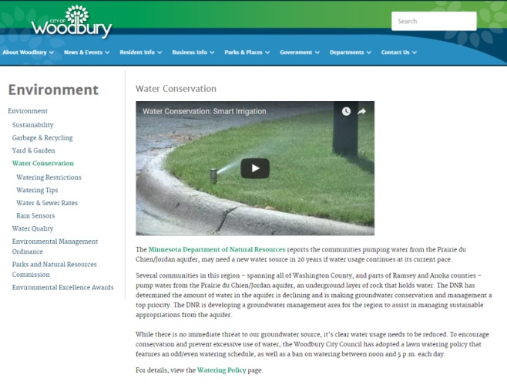](http://ci.woodbury.mn.us/environment/water-conservation)

## Examples of City Water Conservation Webpages

**Woodbury Minnesota**

Woodbury recently updated its website which features a section on water conservation and includes watering restrictions, watering tips, water and sewer rates and information on rain sensors: [Woodbury Water Conservation Website](http://ci.woodbury.mn.us/environment/water-conservation)

**Pequot Lakes**

On the city website, Pequot Lakes provides water conservation tips as well as handouts and materials on water education: [Pequot Lakes Water Conservation Tips](http://www.pequotlakes-mn.gov/index.asp?SEC=5D4BF487-4BCF-4511-8A77-0B62066ABED9&DE=4B3DB0DC-A59C-400A-81BE-0D115C25C2FA&Type=B_BASIC)

**Central Minnesota Water Education Alliance**

The Alliance has developed a webpage on [Clean Water Tips](http://www.mnwaterconnection.com/)

## Reaching Homeowners through Social Media

Several social media platforms exist which can be utilized to communicate with homeowners about water conservation.

Pro Tip:

If using social media, it is important to keep the social media posts active. Try developing a schedule for providing social media posts several times a week and designate specific staff to prepare social media posts.

[***Facebook***](http://www.facebook.com)

Our recommendation is to utilize the existing Facebook online community for the city as the main platform for social media. Post about:

* Events that are coming up
* Work the city is doing
* Efforts being taken to improve lawn irrigation in the community.
* Facts of the day.
* Participatory items such as surveys or quizzes.

Posts should be often, a couple times a week, to keep the message in front of people.

[***Periscope***](http://www.periscope.com/)

In tandem with Facebook, Periscope allows for live streaming and could be used to let people know it’s going to rain and to turn off their sprinklers. Periscope could also be used to keep a message out in front of people. Live streaming allows people to interact and ask questions. The broadcaster can see the questions and can respond back to the questions.

[***Twitter***](https://twitter.com/)

Using Twitter can be beneficial for sharing articles, posting videos, and “retweeting” prominent figures within the community. For example, coordinating messages with the mayor to be tweeted/retweeted might allow the message to reach more community members. Twitter can be used to make more frequent posts, up to several times per day and is an excellent tool for sharing instant real-time updates related to events. [25]

[***YouTube***](https://www.youtube.com/)

Communities have also produced educational YouTube videos to promote and/or feature city efforts to conserve water.

## Sample Materials:

* Sample Facebook Post and Facebook Quiz
* YouTube Videos
* Sample Website Content

### Sample Facebook Post

### 

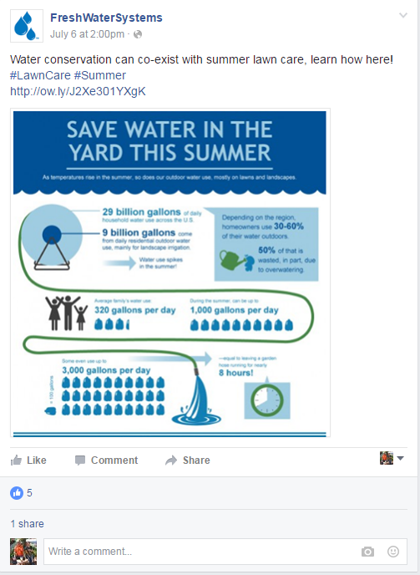

### Sample Facebook quiz

Facebook has some free tools for creating quizzes that can be a fun way to get city residents engaged with the content. These quizzes can be shared by Facebook users who take the quiz and can be no cost teachable tools.

**Recommended application:** Quiz Maker[26] is a free Facebook application that lets you control the inputs and content of your quizzes.

**Quiz Title:** How well do you know your lawn?

**Description:** Take this quiz and find out if you are the best on the block at giving your lawn what it needs to be healthy and green!

**Questions:**

Q: What is one major factor that promotes fungus (mushroom) growth?

A: Abundance of water

Q: Do you know what the two main active elements in fertilizer are?

A: Phosphorus/phosphate and/or nitrogen/nitrate

Q: What is the main nutrient contributor to causing algae and moss blooms?

A: Phosphorus/phosphate and/or nitrogen/nitrate

Q: When is the best time to water your lawn?

A: Between 4am and 8am

Q: Do you want you grass roots to be shallow or deep?

A: Deep

Q: It is best to water your lawn on a consistent basis, no matter the weather situation?

A: No, inconsistent is best

Q: Do you need to water your lawn when it is raining?

A: No

Q: Should your soil be wet down to the depth of 5 inches?

A: Yes

Q: You should be frequently watering your lawn in the spring?

A: No

### Sample YouTube Videos

1. The City of Woodbury is focusing on residential irrigation to teach residents how to set their sprinkles so they are not watering when they should not be. Woodbury produced a YouTube video on Smart Irrigation that shows residents how to use automatic sprinkler systems: [Water Conservation: Smart Irrigation](http://www.ci.woodbury.mn.us/environment/water-conservation)

[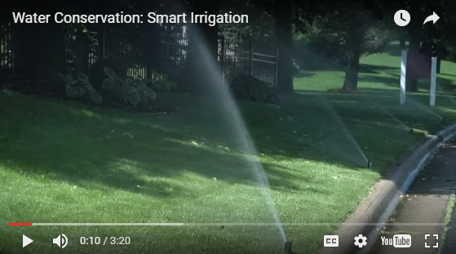](http://www.ci.woodbury.mn.us/environment/water-conservation)

1. Lawn Chair Gardener presentation on eco-friendly gardening by Dawn Pape: [Easy and Eco-Friendly Natives and Edibles](https://www.youtube.com/watch?v=E-Ao_Z9fKg8)

[](https://www.youtube.com/watch?v=E-Ao_Z9fKg8)

### Sample Website Content

**Frequently Asked Questions about Lawn care and Water Use**

**Q: How often should I water my lawn?**

A: Ideally, the grass plants should dictate the watering program. The easiest way to tell is by walking on your lawn. If you see a footprint, this is an indication that irrigation is necessary. It is desirable to keep the intervals between watering as long as possible without allowing the plants to go into stress. Infrequent irrigations cause plants to develop deep, strong root systems that can extract water from a much larger volume of soil than the shallow roots associated with light, frequent irrigations.

**Q: How much should I be watering each time?**

A: The amount of water to apply depends on the soil type and the wetness of the soil. The preferable method is to thoroughly wet the soil down to a depth of 5 inches. If the soil is initially very dry, it may take 1/2 inch of water to wet a sandy soil down to a depth of 5 inches. Any additional water will drain below the root system and is wasted. If you see that the water is running off onto the cement or any other hard surface and/or forming puddles, your lawn is saturated and does not need any more water. An easy method to check how far the water has penetrated your lawn is to sink a shovel into the soil and spread the hole so you can see how far the water has penetrated. Then remove the shovel and press the soil into place with your foot.

**Q: When during the day should I water my lawn?**

A: Water in early, early morning hours for greatest efficiency. The best, most efficient time to water your lawn is between 4am and 8am. During this time less water is lost in evaporation, wind velocities are usually lower, and water demand on municipal systems is usually less at this time.

**Q: When during the year does my lawn need to be watered?**

A: Lawn irrigation should be minimal throughout the spring until June. Your Lawn only needs 1 to 1 ½ inches of water per week (minus any rainfall) during the summer months. Water slowly, deeply and less frequently. Keep the intervals between irrigation as long as possible. It is not necessary to water before, during or at least 1 day after a rainfall.

**Q: Does mowing my lawn affect its water requirements?**

A: Yes. Mow your grass to 2 ½ to 3 inches. This is the single most important thing you can do to improve the health of your lawn. By keeping your grass longer, the roots grow deeper and can reach more water during dry periods. Use a sharp mower blade; it will make the grass plants it less susceptible to disease

**Q: What does it mean if I have mushrooms growing in my lawn?**

A: this typically means that your lawn has been over watered.

# Brochures, Posters and Other Printed Materials

In addition to reaching homeowners online and one-on-one it is also wise to have materials printed to display in the community or provide to homeowners to take home. It is helpful to have printed materials to provide homeowners when they visit city events, during one-on-one meetings, or to send them through the mail as fliers etc. Printed materials can include:

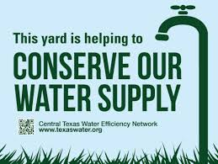

Figure 3: Water Conservation Yard Sign. Source: Central Texas Water Efficiency Network

* Posters hung up in city offices, at grocery stores, coffee shops, schools, and any other gathering places.
* Mailers sent out with water bills or other notices from the city. Can include tip sheet and should direct people to website resources.
* Campaign signs that residents can place in their yards to promote their commitment to water conservation.[27]
* Brochures and fact sheets[28]
* Magnets for the home or garage

**Fact Sheet Outline/Guidelines**

The following list provides some ideas of information to include in brochures or fact sheets:

* Relevant statistics, including comparisons between current per capita water usage and recommended DNR per capita water usage.
* A review of the problem in your community and the negative impacts that it has on local citizens and ecosystems. Use the different messaging appeals (pg. 10).
* Suggestions for decreasing water use.
* Information on where to go for more information such as links to additional online resources.
* Description of how water conservation benefits both humans and the environment.

## Sample Materials

* Sample Flier
* Sample Mailer
* Sample Brochures
* Sample Articles

### Sample Flier: Water You Doing to Conserve?[29]

10 top ways to save water outdoors

Minnesota may be a water-rich state, but our ground water supplies are limited and are slow to recharge. Reducing how much water we use on our lawns and gardens can help to preserve our water supplies for current and future generations. The following are some of the most effective ways to reduce outdoor home water use and waste.

1. **Only water your lawn when it needs it.** Most lawns only need 1” of water/week from all sources combined. Avoid watering just because it’s your (odd/even/city-designated) day to do it. Place an empty tuna can on the lawn—or use a rain gauge—to measure.
2. **Find & Fix Leaks.** Leaks in hoses, spigots, couplings, sprinkler heads and similar, can waste 140 or more gallons of water/week. Use hose washers at connection points and spigots to help reduce leaks.
3. **Replace water-loving turf grasses with drought-tolerant plantings.** Consider using native and/or climate-appropriate plants, grasses and ground covers.
4. **Use micro-irrigation techniques.**  Traditional spray sprinklers can waste a lot of water due to evaporation, wind, and runoff. Soaker hoses, micro-sprayers, drip tape and similar keep water close to plant roots, where it’s most needed and effective.
5. **Install rain barrels at gutter downspouts**. By substituting rain water for drinking water, rain barrels and cisterns help us to conserve our ground water supplies.
6. **Apply 2 ½ -3” of mulch around plants and trees, and mow high.** Mulch keeps plant roots cooler and helps to retain moisture. Keeping grass at 2 ½ inches or higher when mowing helps to shade plant roots and leads to deeper, more water-efficient root systems.
7. **Don’t water the pavement**. Position sprinklers so that they only water living plants, not gutters or paved areas.
8. **Groups plants with similar watering needs.**
9. **Fertilize lightly and infrequently**. Fertilizer results in faster growing plants, which require more water.
10. **Install a WaterSense-labeled irrigation controller.** If you have or plan to install an automatic sprinkler system, invest in a U.S. EPA WaterSense-labeled controller, which saves water by using weather and landscape conditions to determine when plants need water.

### Sample Letter to Homeowners

City of

**RE**

**Lawn Sprinkling Guidelines**

The utility bills for June and July contained inserts describing legislation that requires water utilities to take actions that will promote water conservation; a discussion on how water charges are determined; and a description on how individual residential customers can compare their water usage to other typical residential customers. This insert will include guidelines for efficient and cost effective lawn sprinkling. Future inserts will include additional information on our water treatment, storage and distribution facilities, as well as other actions individuals can take to conserve water.

Lawn sprinkling can more than double the daily water usage on a utility-wide basis during dry, hot periods. Sprinkling can also have a dramatic impact on the water and sewer usage portions of an individual utility bill. The intent of this insert is not so much to discourage sprinkling, but rather to provide information which will help make sprinkling more efficient, effective and less costly. The overall goal is to provide sprinkled areas with the water desired, while at the same time, minimizing the water loss due to runoff, evaporation and excessive infiltration.

The generally accepted rule of thumb is that 1" of precipitation per week is adequate to maintain a healthy lawn. While this may not seem like much, 1" of water over a 1/3 acre lot corresponds to 600 cubic feet of water. This is based on the assumption that approximately half of the lot is actually watered. The resulting water usage charge for each inch of water is approximately $20. The sewer charge could also add an additional $20; however residential sewer charges are limited to 140% of the winter time usage.

The following lawn sprinkling recommendations are promoted by the Minnesota Department of Natural Resources. These recommendations are provided to assist those residents that desire to water their lawn with the information to do so in a manner that provides the maximum benefit, and is cost effective for the utility, as well as the individual.

**General Information**

* Adjust sprinklers to water only grass areas and not impervious surfaces such as streets, driveways and walkways.
* Mow to a height of 2-1/2" to 3". Taller grass shades the roots and soil surface, which helps reduce the amount of water that is lost to evaporation.
* Use sprinklers that spray low large drops vs. high fine ones.
* Use hand held soakers for small trees, shrubs and plants.
* Use shut off nozzles and repair leaky hoses and fittings.

**When to Water**

* About one inch of water per week (including precipitation) is adequate for maintaining a healthy lawn. Use a can or rain gage to determine the amount of water applied by the sprinkling system and supplied by rainfall.
* Don't use a fixed schedule for lawn watering. Apply water only when it is needed. Over watering can promote diseases and affect the health of the lawn.
* A simple test for determining if grass needs water is to walk on the lawn and if you leave foot prints, it may be time to water.
* Using a spade or gardening tool to check soil conditions 2 to 6 inches below the surface can provide information on soil moisture and the need for water.
* A good soaking once or twice a week is better than watering every day. Allowing the soil to dry between watering will allow roots to grow to greater depths and help make turf more
  + Drought tolerant.

**Best Times for Watering**

* Water during the cool part of the day to minimize water lost to evaporation. Early morning hours (4 a.m. to 8 a.m.) are the best, and the peak water consumption hours (4 p.m. to 9 p.m.) should be avoided.
* Avoid watering during midday hours when it is hot and sunny to prevent scalding the turf.
* Watering at night is not recommended because the lawn stays wet for a long period of time which can promote diseases and affect the health of your lawn.
* Avoid watering during rainy or windy weather conditions.

**Automatic Lawn Watering Systems**

An automatic timer is part of most buried sprinkler systems, but can be added to any sprinkler system for a relatively low cost. Automatic timers make it easy to set sprinkling systems to apply specified amounts of water during the best times of the day.

* Set systems to turn on between 4 a.m. to 8 a.m.
* Set systems to turn on water for three-10 minute sessions with each session % hour apart to improve infiltration and reduce runoff. ·
* Equip the system with moisture sensors so the system does not turn on when it is raining.
* Set the automatic timer to water every 3 to 4 days adjusting the time and frequency as needed, to accommodate changes in seasonal water demand.
* Adjust individual spray heads to make sure water is applied only to those areas that need it and does not run-off.

**New Lawn and Landscaping Alternatives**

* Adding organic matter before seeding will improve water and nutrient retention.
* Reduce water requirements by using drought-tolerant grass seed and sod.
* Reduce turn areas by planting drought-tolerant trees, shrubs and plants.

*Source:*  <http://www.dnr.state.mn.us/waters/watermgmt_section/appropriations/conservation.html>

This website also has general information on other water use reduction measures that individuals can take, as well as information of the water use reduction goals that the legislature included in the state Statute.

Please contact me with any other suggestions or ideas you might have for future water conservation related utility bill inserts. The insert next month will include a general description of the water supply, treatment, storage and distribution infrastructure Red Wing has, and will include the time and date for an open house at the Twin Bluff Water Treatment Plant. My telephone number and email address are (000000000002 and jjjjjjjjjjjjjjjjjjjjjj.[30]

Website: [www.red-wing.org](http://www.red-wing.org/)

### Sample Brochures

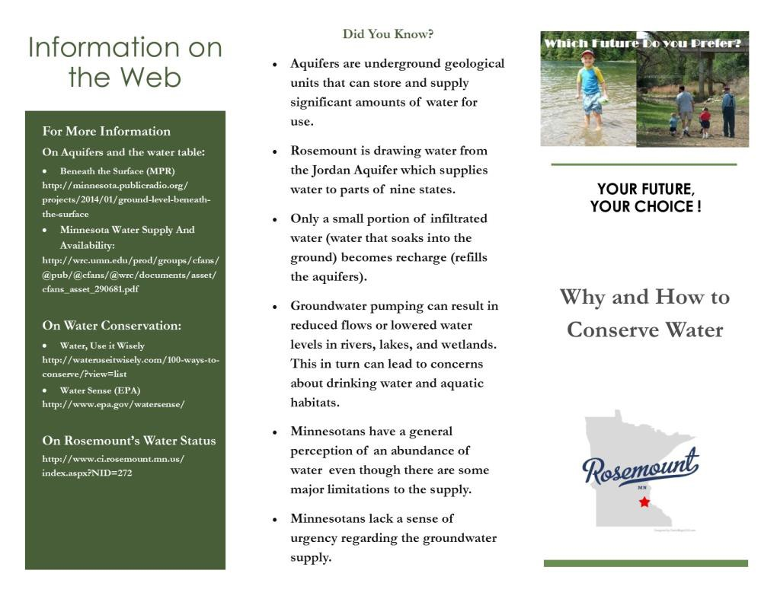

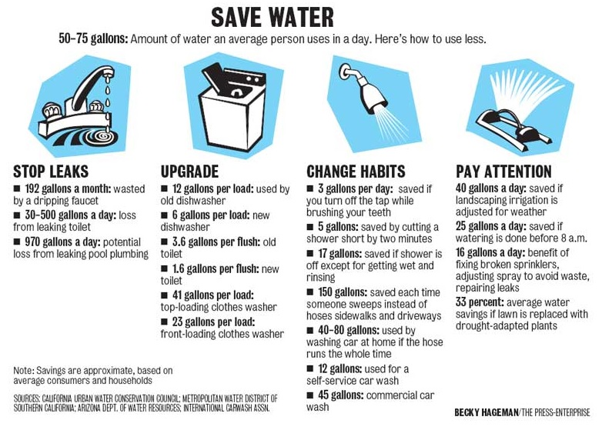

### Sample Articles about Water Conservation

[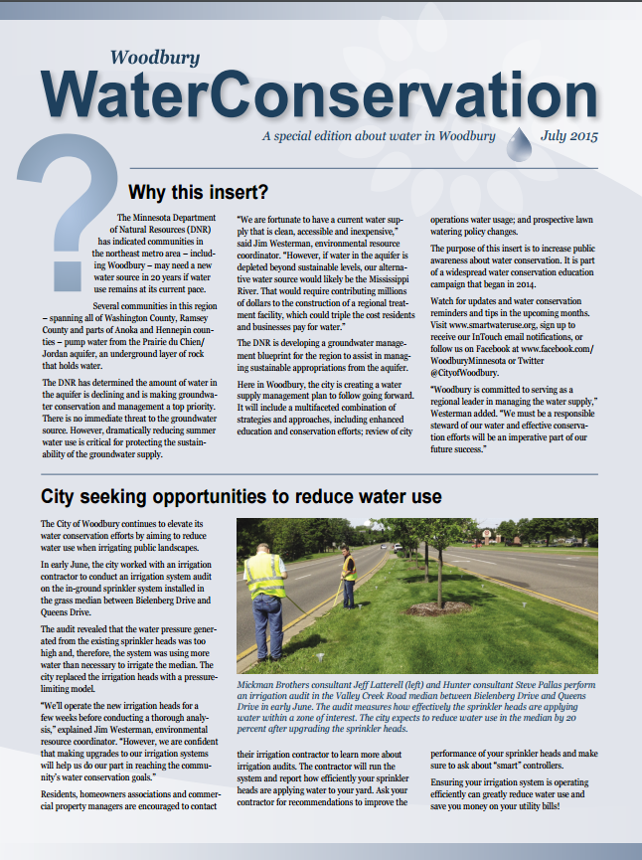](http://ci.woodbury.mn.us/images/conservation-july15.pdf)

**The City of Woodbury**

Woodbury recently sent out a water conservation insert in July, 2016: [Woodbury Water Conservation](http://ci.woodbury.mn.us/images/conservation-july15.pdf)

Woodbury also recently published the following article focused upon lawn care: [Woodbury Water Efficiency](http://www.ci.woodbury.mn.us/images/waterefficiency16.pdf)

**Stillwater**

The following article by Angie Hong, East Metro Water Resource Program/Washington Conservation District about water conservation was published in the Stillwater Gazette: [Drinking Dinosaur Pee](http://stillwatergazette.com/2015/12/07/drinking-dinosaur-pee/)

# Conducting Water Conservation Presentations, Seminars and Events

The next level of outreach involves in-person group seminars, presentations and events. Seminars and presentations are typically focused upon the community members who are invested in making a change but may need more information or help creating an action plan to change their irrigation habits. The objective of a community outreach event is to create awareness of the problem, the need for a change in behavior, and provide education on ways to change. The most important aspect of the event is to convince attendees the problem is real and that the residents can make a difference.

It is a good idea to partner with community groups or local home owners associations to help promote and host presentations or events. The city can either organize stand-alone water conservation events or attend pre-established community events.

## Attending Pre-Established Community Events

Some examples of pre-established community events that may provide the opportunity to engage homeowners include:

* Community Festivals
* City Council Meetings
* Classic Car Night
* Movies in the Park
* Concerts in the Park
* Business Community Coffee Hours
* Farmers Markets

As alluded to, attending community events and setting up a booth is important for outreach. We recommend coordinating with the organizers of community events to set up a booth where you can hand out printed materials, campaign signs, promotional items, as well as collect information from residents who want more information and help.

## Planning an Event

When planning an event or community presentation there are several factors that must be considered including the location and time, the target audience, incentives and promoters, presenters and refreshments The following section provides guidelines for designing an event to educate residents about home water conservation.

**Location and Timing:** The event should be held in a high profile location that the public enjoys visiting and that demonstrates the significance of the issue. The location and time for the event should also be selected based upon convenience of the target audience. Examples of meeting places can include city hall, a local library or community center, a community college or university etc. While longer seminars may require a stand-alone event, shorter presentations can also be added to existing meetings in the community such as city council meetings. Think about the availability of your target audience when scheduling a seminar or presentation. For example, a meeting at 11:00 AM on a Wednesday may not be convenient for homeowners with full-time jobs. We recommend holding the event on a weekday evening or weekend to minimize conflicts with resident’s work and family schedules.

**Target Audience:** While homeowners are the target audience of this guide, all residents should be welcome at the community event as they all have the potential to make an impact. Invite homeowners that have expressed interest in water conservation. In addition, it is wise to reach out to key groups such as homeowners that have known problems with water overuse or high water bills or home owners associations that can communicate the information to many individuals. Golf course owners and condo associations would also benefit from water conservation information.

**Promotion:** For small scale presentations or seminars, invite participants using a variety of platforms in including phone calls. For a presentation, make sure to send out a reminder call or email prior to the event.

For a larger scale event, in order to engage a large percentage of the community, the larger scale events will require heavy promotion. The recommended methods are print and online advertisements, as well as posting flyers in public locations or street banners. The following are a number of recommendations for advertising locations:

* City newsletter
* City website
* Social media (Facebook, Twitter)
* Church newsletters or bulletins
* Community education bulletin
* Radio announcements from local station
* Businesses with bulletin boards (supermarkets, thrift stores, etc.)
* Places of worship
* Libraries
* Community and technical colleges

These materials should cover the following information:

* Time
* Location: Address, name of building and room
* Name of organizations that will be present, speakers or presenters
* Incentive offered for attending the event
* If the event will be cancelled in inclement weather

**Presenters:** Presenters can be from the local city or from outside of the community. We recommend that the instructor or presenter be presented as a subject matter expert. We also suggest having at least one attendee who is well-known and well-respected in the community.The presenter should be a familiar and charismatic community leader, if possible. Speaking ability (and persuasive speaking ability in particular), is more important than technical knowledge. If that type of person is available to speak, we recommend having subject matter experts in the audience or on stage to support the speaker with answers to any technical questions the audience might ask. It would also be valuable to have someone with a powerful personal water story to tell as part of the event. One example would be to have a homeowner speak briefly about his or her experience.

**Refreshments:** We recommend that some sort of food or refreshment be made available for the attendees.

## Examples of Water Conservation Events in Minnesota

**White Bear Lake Water Conservation Event[31]**

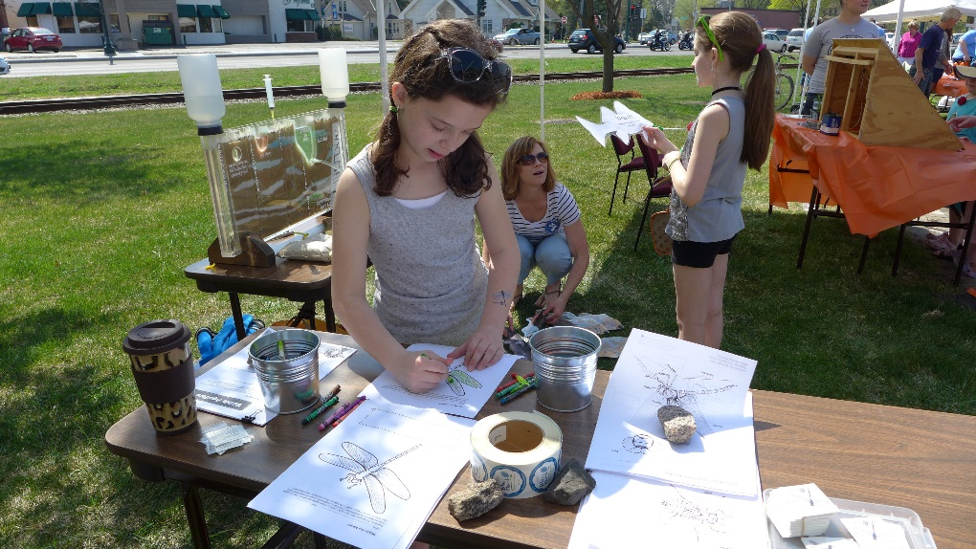

Figure 4: White Bear Lake Water Conservation Event, 2015. Source: <http://www.vlawmo.org/events/2015/>

The goal of the Water Conservation event is to promote water conservation and water quality through brochures, interactive displays, kids’ activities, workshops, and giveaways; and to provide resources and guidance to help residents implement water conservation and water quality measures on their property (i.e. information on cost share assistance, rebates, low cost rain barrels, native plants, water efficiency practices, etc.). The city gives away milkweed plants, sells rain barrels, and conducts a half hour rain barrel workshop during the event. Vendors from last year’s event include: Met Council, Race to Reduce/H2O for Life, Ramsey Conservation District, Vadnais Lake Area Water Management Organization, Cedar Hill Natives, DNR, White Bear Lake Conservation District, White Bear Area Chamber of Commerce, Rice Creek Watershed District, Ramsey Washington Metro Watershed District, and the Washington Conservation District.

**Anoka:** County Environmental Services organized and hosted a Smart Irrigation forum[32] in July for school districts, condo associations, etc.

## Sample Materials

1. Water Conservation Education Displays
2. Sample PowerPoint Presentation
3. Lesson Plans for a longer In-Person Seminar

### **Water Conservation Education Displays**

When attending or hosting outreach events or presentations it is helpful to have a visual. The Washington County Conservation District[33] has developed new groundwater educational displays. The displays are available to be checked out for educational events. Sign up to reserve the displays using the following online calendar: <http://www.mnwcd.org/emwrep-resources>

While some of the content is Washington County specific (i.e. the pull out map), the display provides a useful example and a helpful explanation of groundwater which can be used at educational events.

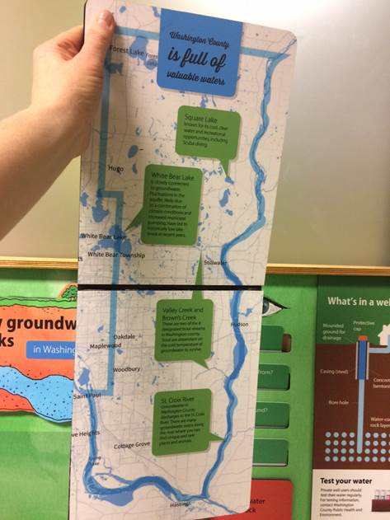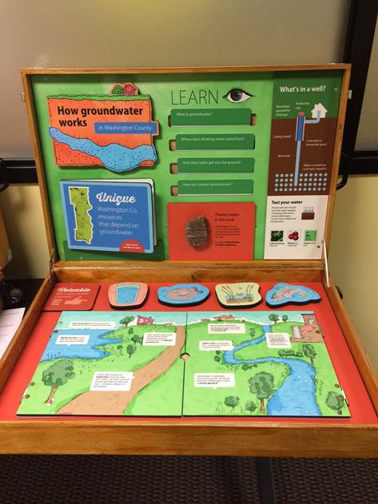

### **Sample PowerPoint Presentation**

This a guideline is meant to help visualize recommendations for the structure and format of a presentation and discussion about household water conservation. While this sample PowerPoint does not focus exclusively upon lawn irrigation, it provides a helpful example for cities to refer to.

The format of the presentation, in general, is as follows:

* **Engage the audience’s experience:** Start with a personal or community water story. A personal story will engage the audience’s emotions and help them to see the urgency of the situation. It is imperative that the presenter manage the timing of the presentation well, so storytelling does not take up the entire allotted time. We provided an opening question to help engage the audience to relate personal stories. It would be beneficial to have as many residents as possible respond to this question and be allowed to have their voices included in the conversation.
* **Water education:** This slide provides brief background information on clean water with the intention of helping people understand how clean water is created so they can see why it is so critical to start conserving water today.
* **Relevance:** This slide provides a link between the behavior of the audience and the problem. We hope it will help the audience to personalize the situation and create a sense of urgency.
* **Call to action:** This slide should help the audience see that they can make a significant difference in Rosemount’s water consumption and motivate them to begin immediately.
* **Assessment:** On the last slide, we provided a quiz to help assess whether or not the transfer of learning of certain key points occurred. In addition, the quiz provides an opportunity to interact further with the audience in a fun and nonthreatening way.

There are many ways to facilitate the transfer of learning. Storytelling is an effective way of both capturing the audience’s attention and facilitating their retention of the information. We encourage you to limit the data driven information and focus instead on personalizing the situation. We think the event should be as interactive as possible within the time allotted. Repetition is another effective method of improving transfer of learning.[34]

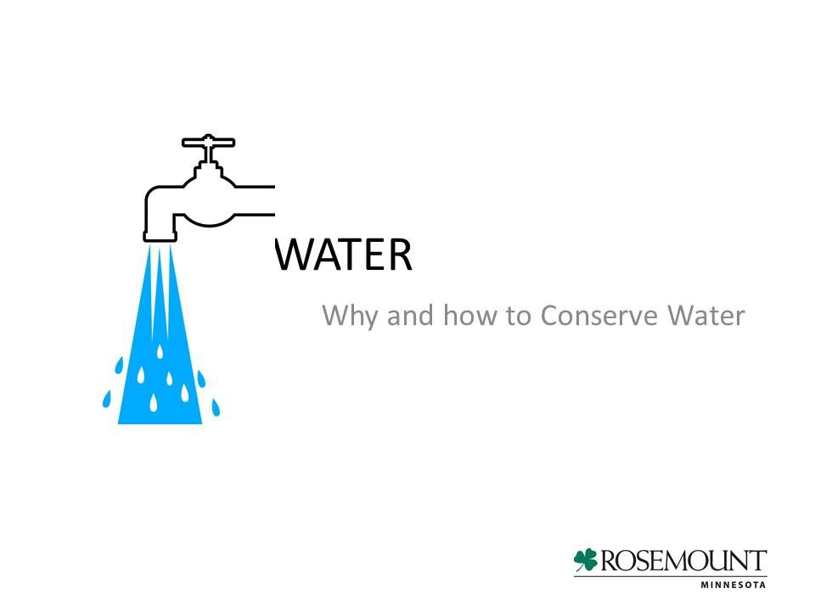

**Slide 1: Tips**

* Written Information on the slides should be kept to a minimum. Pictures, graphs, and diagrams are generally more effective. Text font should be 28 or 32 point size, with titles being 36 to 44 point size.
* Stories usually make more of a lasting impression on the audience than statistics. Stories relating to the experiences of the audiences will be most effective.

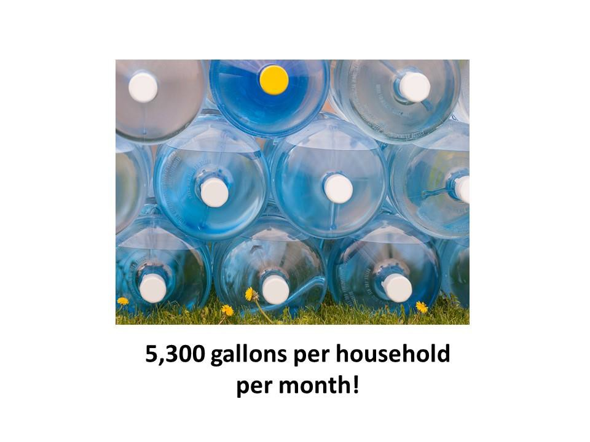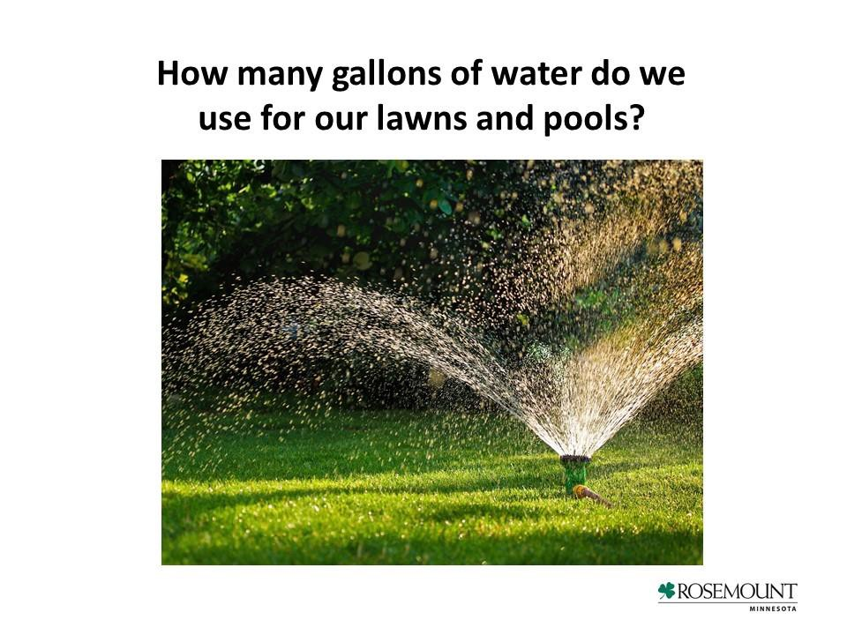

**Slide 3: Identifying target area for behavior change.**

* Note that “each household uses approximately 5,300/month in the summer months for lawn care & pools. This is *in addition* to normal water usage.”
* You could give examples of other things that hold approximately 5,000 gallons to help the audience visualize the quantity of water they are using.

**Slide 2: Engaging the experience of the audience.**

Questions you might ask include:

* How do you water your lawn?
* How do you decide when to water?
* How much water do you think you use?

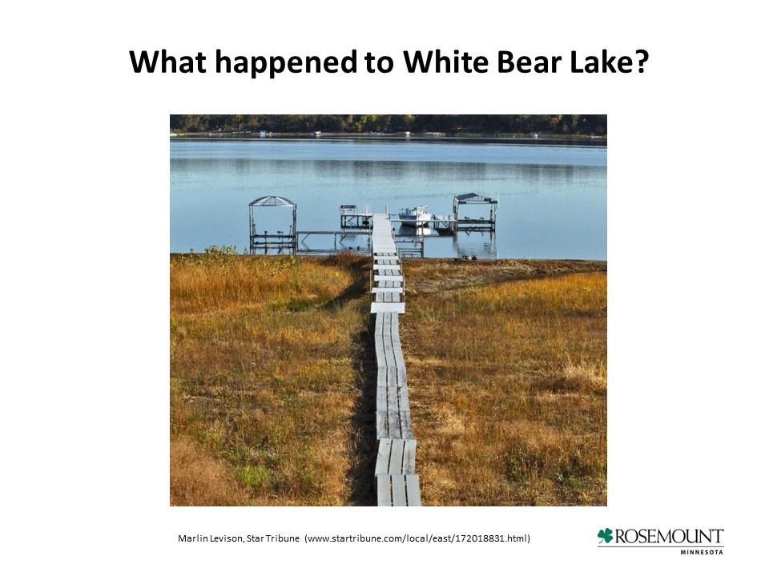

**Background Slide: Help the audience understand a few technical details.**

Answer: It can take from days to years.

A demonstration of the water filtering process could be effective here. Interesting facts about the process may include items such as:

* Aquifers are primarily recharged by precipitation
* MN experiences drought occasionally, which dramatically slows the recharge process.
* Demand is high. One aquifer supports multiple wells and states.
* Supply is limited.
* Cities in Minnesota including Marshall, Worthington, and Chanhassen have experienced dry wells due to aquifer shortages

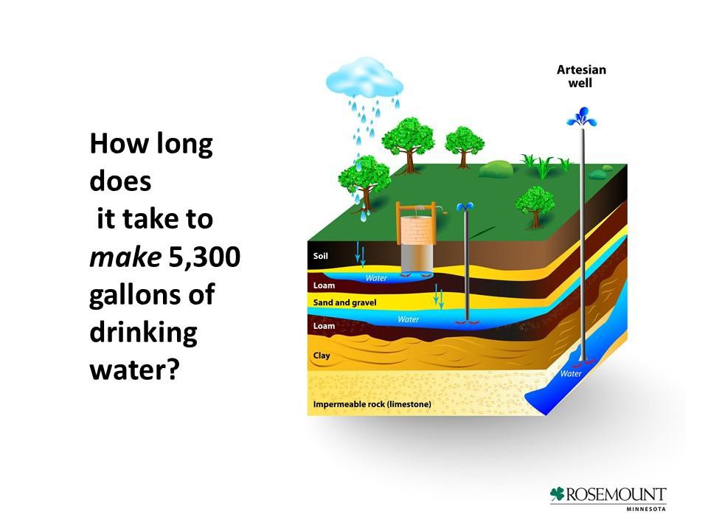

**Story to demonstrate relevance and create a sense of urgency.**

A story like this can make a huge impact on the audience as far as seeing the need for change. This is a good point for an interactive discussion.

Questions you might ask include:

* What have you heard about the decrease in White Bear Lake?
* How quickly did the change happen? *5.5 feet in 7 years*
* What do you think caused it? *Low precipitation and increased pumping due to residential growth.*
* What was the impact on homeowners? *Need for longer docks, concern over property values, lawsuit against DNR over water mismanagement*
* Could something similar happen in or near your city?
* What other lakes are experiencing similar issues? *Turtle Lake, Chisago Chain of Lakes, and Marine Lake*

**Transition from the problem to the solution.**

Key messages may include:

* There is a positive outlook if we conserve now.
* We can change the future.
* A few small behavioral changes can make a big difference.

If choosing to do an interactive exercise at the end to reinforce key points (target behavioral changes), this would be a good time to inform the audience.

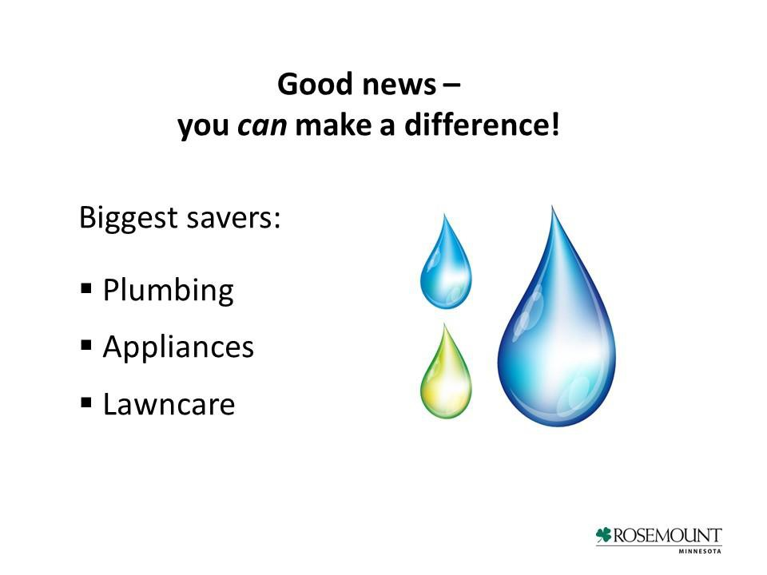

**Conservation tips related to plumbing.**

Some interesting facts may include:

* Doing routine leak inspections can save up to 500 gallons per month.
* Low flow toilets together with aerated faucets and showerheads save up to 1,200 gal/month

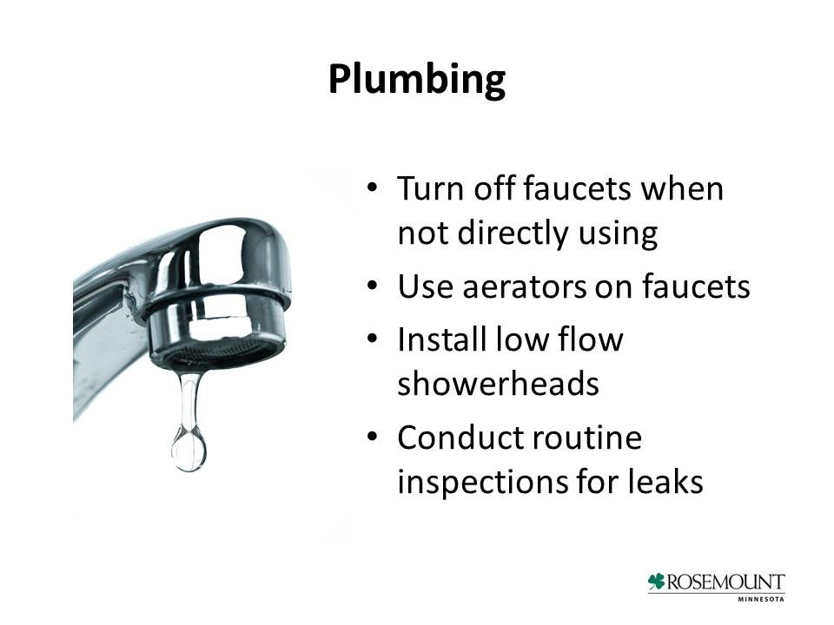

**Conservation tips related to appliances.**

Some interesting facts may include:

* Running washing appliances only when fully loaded can save up to 1,000 gallons/month!
* Low flow toilets, faucets, showerheads save up to 1.200 gal/month.
* Rebate information, if applicable, from local utilities for buying efficient appliances.

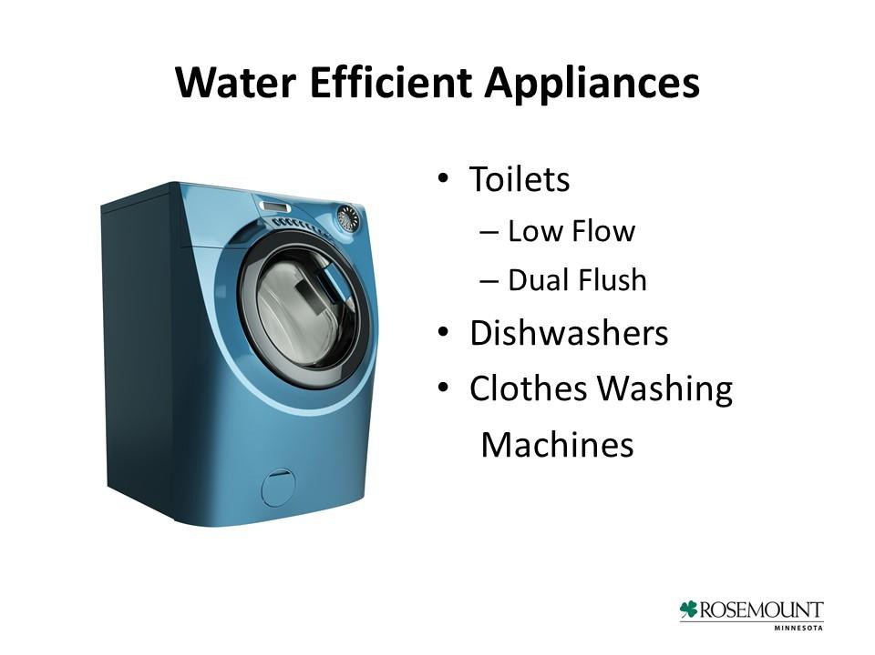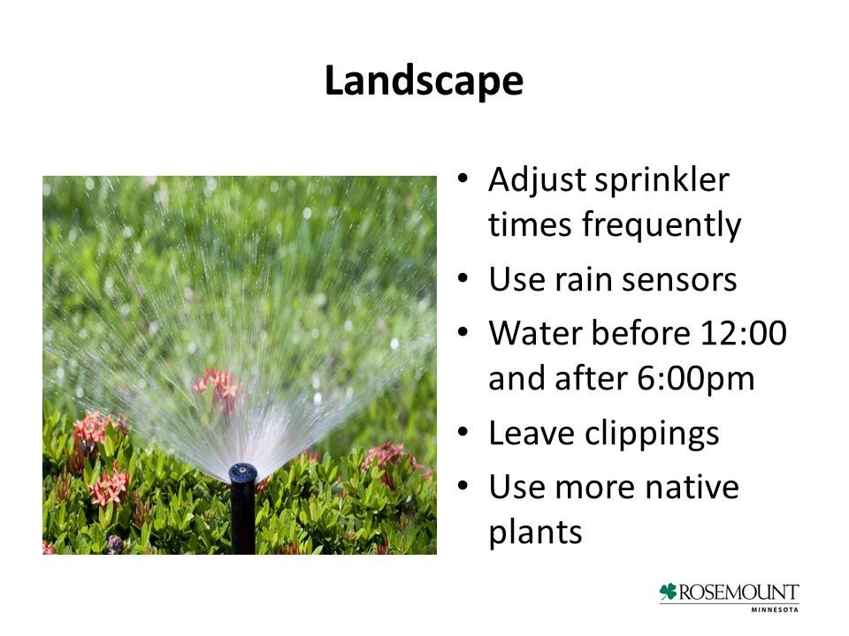

**Conservation tips related to lawns.**

Instruct audience on the right way to water a lawn. Other key points may include:

* Impact of the seasons
* How much water to use
* How to utilize cycling
* Examples of native plants that make the biggest impact

Depending upon time, a lot of education could be done here and each tip alone could easily be a separate slide or more. These might be good topics for future meetings.

.

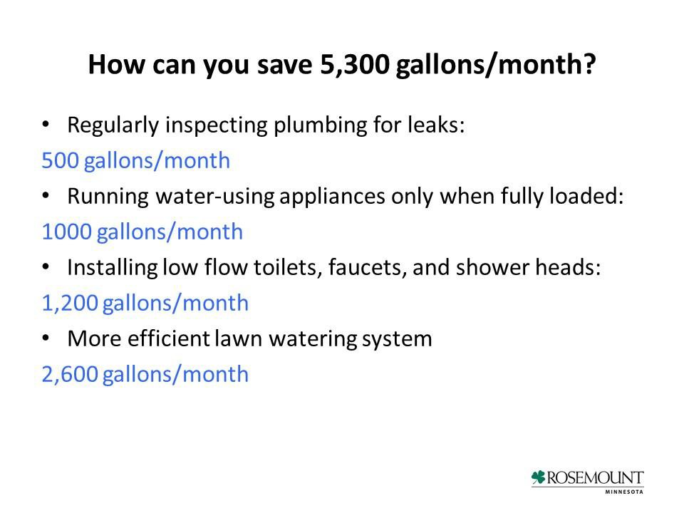

**Evaluate learning transfer.**

The objective here is to both to evaluate whether or not the audience absorbed the information discussed and to reinforce those key points (conservation techniques) one last time. The audience should be asked the question and responses noted. Then the responses can be compared to those on this slide. The numbers don’t have to be exact. They key is to discuss how the audience can make small behavioral changes that will produce the desired impact.

At least 15 minute should be allowed for questions at this point.

Depending upon the speaker, subject matter experts could also be invited to the front of the room at this point.

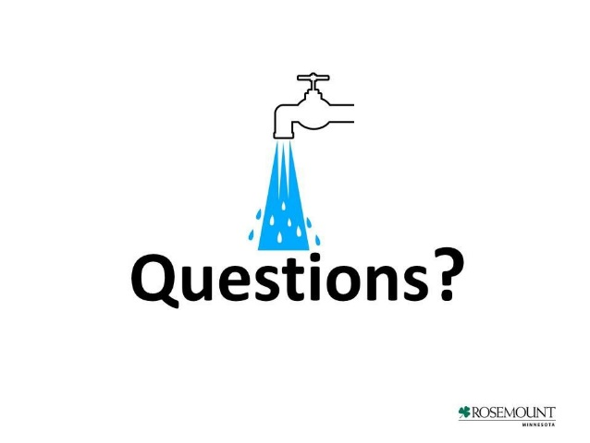

### Sample Lesson Plans for In-Person seminar:

This Lesson plan is broken into three sections:

* *Part I: Water Conservation and Ecological Effects*
* *Part II: Lawn Care Tips*
* *Part III: Smart Technologies[35]*

*Part I - Water Conservation and Ecological Effects*

|  |  |  |  |
| --- | --- | --- | --- |
| Lesson Online | Lecture Topics | Resources and Expansion on Topic | Time |
| Introduction | **How does over watering your lawn negatively impact the environment around you?** | Think about how it can affect wildlife, the landscape, and aquatic features. | 2 min. |
| Presentation 1 | **What happens to your lawn becomes waterlogged or has mushroom growth** | Waterlogged soils restricts root growth, promotes some diseases, and allows algae and moss to thrive (Hartin, Geisel, & Harivandi, 2011). Also enables other types of fungus that can be more serious problems for your lawn (The Scotts Company LLC, 2016). | 2 min. |
| Presentation 2 | **What happens to the nearby lakes and rivers from runoff. Fertilizers leached from soil draining into lakes and streams** | Excessive over watering removes excess nutrients from your lawn, especially if your lawn is on top of sandy, coarse textured soils including clay (Rosen and Horgan, 2016 )  Over usage of fertilizers can also infiltrate into lakes and streams through runoff and drainage from over watering (Rosen and Horgan, 2016).  Proper application and soil testing can reduce the possibility of pollution (Rosen and Horgan, 2016).  Excess nutrients, especially phosphorus and nitrogen, in drinking water can cause an infant’s body to lose their ability to use oxygen (Rosen and Horgan, 2016).  Too much nitrogen can create an ideal environment for fungal growth (The Scotts Company LLC, 2016). | 5 min. |
| Presentation 2  (cont.) | **This can cause adverse effects to aquatic wildlife and the overall health of the body of water** | “Excessive nutrient inputs, usually nitrogen and phosphate, have been shown to be the main cause of eutrophication over the past 30 years” (Oram, 2014).  This process causes algae blooms, unpleasant odors, water discoloration, aquatic life to suffocate and die, and some types of algae to produce toxins that can be harmful if ingested (Minnesota Pollution Control Agency).  “This may result in declines in fishing and swimming and hurt tourism” (Minnesota Pollution Control Agency). | 8  min. |
| Presentation 3 | **MN laws restricting the use of phosphorus fertilizers on lawns** | “In an effort to reduce phosphorus runoff to surface waters, the Minnesota state legislature passed laws in 2002 and 2004 that restrict phosphorus fertilizer use on lawns” (Rosen and Horgan, 2016).  “Because most lawns in Minnesota already test very high in phosphorus, the Minnesota legislature passed a statewide law that restricts the application of phosphorus fertilizer to established turf. Note, this law does not pertain to phosphorus use in gardens” Rosen and Horgan, 2016).  “Current law allows application of phosphorus fertilizer to turf during the establishment year”(Rosen and Horgan, 2016) | 5 min |
| Presentation 4 | **Overwatering can lead to drying up the local water table and aquifer.**  **Excessive pumping can overdraw the groundwater**  **Reduction of water in streams and lakes** | The City of Victoria is in the process of identifying a site to drill a fourth well to accommodate the over use of water in the summer months  The volume of groundwater in storage is decreasing in many areas of the United States in response to pumping. Groundwater depletion is primarily caused by sustained groundwater pumping. Some of the negative effects of groundwater depletion:   * drying up of wells * reduction of water in streams and lakes * deterioration of water quality * increased pumping cost * land subsidence (United States Geological Survey)   By using excess water, we are taking away groundwater that contributes to the flow of streams. Pumping too much water because of over use does not allow for groundwater to replenish itself in aquifers, and alters the flow of water and can lower the levels of water in streams, lakes, and wetlands. This can have adverse effects on the habitat, plants, and wildlife (United States Geological Survey). | 10  min. |
| **Case Study** | **White Bear Lake** | “White Bear drains a very small watershed and has always had big decreases in area and volume during extended dry periods when rainfall and melting snow do not keep up with evaporation.  Chemical testing of water from wells around the lakes confirms that lake water is flowing out the bottom of the lake into groundwater aquifers that feed those wells.  Pumping from high-capacity wells in suburban communities that mostly draw their water from those aquifers more than doubled over the last 30 years.” There are varying scientific opinions, but some believe as much as 25% of White Bear’s water volume may have been lost from below due to increased groundwater pumping in the aquifer below the lake.” (Huttner, 2012) | 5 min |

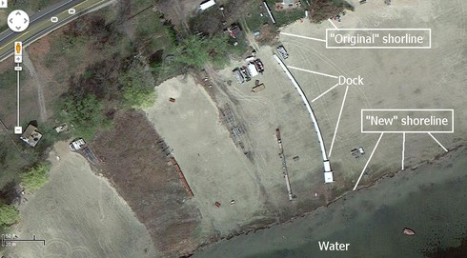

Figure 5:Google Earth image of White Bear Lake approx. 2012

*Part II - Lawn Care Tips*

|  |  |  |  |
| --- | --- | --- | --- |
| Lesson Online | Lecture Topics | Resources and Expansion on Topic | Time |
| Introduction | **What are best practices for lawn irrigation?** | Think about experiences you’ve had with your irrigation system, or watering your lawn. How often do you water? How much do you water? | 5 min. |
| Presentation 1 | * **Proper lawn irrigation** * **How much water is needed?** * **When to water your lawn** * **Best way to water your lawn** | Watch lecture and PowerPoint Respond to questions. | 15 min. |
| Participant Activities | **Provide scenarios for different weather conditions** | Group Break out-discussing best way to care for lawn regarding their scenario | 10  min. |
| Review | * **Summary** * **Questions** * **Revisit elements of best lawn irrigation practices** | Respond, comments, questions. | 5 min. |

*Part III – Smart Technologies*

|  |  |  |  |
| --- | --- | --- | --- |
| Introduction | **Lecture**   * **Features of smart irrigation systems** * **How it works to save water and money**   **What to look for if purchasing own** | Share some examples of smart irrigation or smart control systems. Ask if anyone has used them, or is aware of these options. | 10  min. |
| Cost Comparison Examples | **Lecture**   * **cost of water** * **how much water is wasted by not setting up irrigation system properly** * **what cost could be if rate structure changes**   **Video:** [**https://www.youtube.com/watch?v=bNVqRItRb**](https://www.youtube.com/watch?v=bNVqRItRb-0)**-** [**0**](https://www.youtube.com/watch?v=bNVqRItRb-0)  [**http://irrigreen.com/Consumers/**](http://irrigreen.com/Consumers/) | Watch lecture and video Respond to questions.  Discussion - anyone willing to share their water bills? What would they rather spend that money on? | 10  min. |
| Participant Activities | **Demonstrate technology. Walk through process of researching, where to purchase, how to install & set-up, and how to monitor throughout summer.** | Group - Discuss any barriers to installing one for themselves. How to remove those barriers.  What can you do next? Immediate action! | 10  min. |
| Immediate Action! | **Explain benefit of grant, who is eligible, how the drawing works.** | Have people sign up for drawing or provide information if interested in getting new smart system. | 5 min. |
| Review | **Summary, Questions, Revisit cost comparison** | Respond, comments, questions | 5 min |

# Evaluating Homeowner Outreach

Assessment is a critical component of the program in order to determine whether the desired learning objectives were achieved. This is helpful to both evaluate the immediate reaction to outreach efforts and gauge long-term behavior changes that may have occurred due to outreach. The following section provides guidance for developing an outreach evaluation plan.

**Prior to Conducting Outreach**

Prior to beginning outreach informal focus groups or interviews can be used to test outreach materials. If this is done use the following questions to evaluate the materials:

1. Did you think you overwatered your lawn before reviewing this information?
2. What best practices can you take away from the information and implement right away?
3. Is there any information that you would have liked to see presented about lawn care that was not provided?
4. Was this information useful to you?
5. Is this information going to change the way you water your lawn? Why or why not?

**Immediately after the event:**

After an event or presentation we suggest distributing a survey to attendees. A survey will help gauge the attendees’ immediate reaction to the event and whether or not learning objectives were met. Questions should address topics such as venue, content and delivery**,** and motivation to change. Some questions to use could include:

1. Which water conservation methods are you likely to use?
2. How has your attitude about water conservation been changed?
3. Was enough information presented to help you understand the need for water conservation?
4. Was there enough time to answer your questions about water conservation?
5. Was the time and location of the event suitable?

**Six months to a year after outreach:**

We urge the city to conduct a survey to evaluate long-term resident awareness of water conservation, retention of key points made during the outreach campaign, and motivation to change irrigation practices. To encourage participation a small incentive or chance at an incentive should be offered to the residents for completing the survey. We recommend using a simple online survey tool to create a survey that can be accessed by the attendees via a link provided in the email from the city.[36] Questions to ask include:

1. What changes have you made since the phone call/meeting/seminar?
2. Which message (financial/ecological/technological) appealed to you most?
3. How do you feel about the water conservation project as a whole?
4. How do you feel about your participation in the water conservation?
5. What information do you still feel like you are missing?
6. What barriers were most challenging to overcome in changing your lawn watering habits?

# 

# Additional Resources

[**Project W****ET**](http://www.dnr.state.mn.us/projectwet/index.html)Project WET (Water Education for Teachers) is an international water science education program that provides resources and conducts trainings on hand-on water education activities for kids and adults. The activities can be used in both formal classroom settings and more informal settings. MN Project Wet is working to improve Minnesotans’ understanding of the state’s water resources. The DNR encourages cities to have at least one staff member attend a training with Project Wet. In addition Project WET and Ecolab recently partnered to create the free [Clean and Conserve Activity Guide](http://www.projectwet.org/cleanandconserve) for educators.

**[](http://www.dnr.state.mn.us/)**[**Minnesota DNR**](http://www.dnr.state.mn.us/waters/groundwater_section/sustainability/index.html) The Minnesota Department of Natural Resources provides a variety of resources for city including a water supply plan templates, guidance on demand reduction measures, sample ordinances, lawn watering tips, and other resources on sustainability and water conservation.

**[](http://www.metrocouncil.org/)**[**Met Council**](http://www.metrocouncil.org/Wastewater-Water/Planning/Water-Supply-Planning/Guidance-Planning-Tools/Water-Conservation/Toolbox.aspx?source=child) The Metropolitan Council [Water Conservation Toolbox](http://www.metrocouncil.org/Wastewater-Water/Planning/Water-Supply-Planning/Guidance-Planning-Tools/Water-Conservation/Toolbox.aspx?source=child) provides a variety of tools for residents and businesses including water supplier suggestions, games, teacher resources, water conservation programs, plumbing codes, and resources for ordinances, zoning and planning.

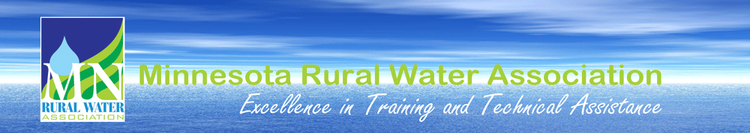[**Minnesota RWA**](http://www.mrwa.com/waterconservation.html) The Minnesota Rural Water Association provides a variety of resources for cities such as sample conservation ads, bill stuffers, sample ordinances, water audit resources, financing options, water rate analysis resources, graphic services and mapping.



[**GreenStep Cities**](http://greenstep.pca.state.mn.us/)The Minnesota GreenStep Cities program offers resources to cities working on a variety of sustainability efforts including storm water management, water conservation, and surface water quality.

[**CNT**](http://www.cnt.org/) The Center for Neighborhood Technology (CNT) is an urban sustainability nonprofit based in Chicago, Illinois. CNT provides resources related to addressing leaky pipes, water supply and stormwater management. CNT also produced the [RainReady Nation](http://www.cnt.org/sites/default/files/publications/CNT_RainReadyNation_0.pdf) project which provides practical solutions to local individuals and businesses.

[**Geological Survey**](http://www.mngs.umn.edu/county_atlas/countyatlas.htm)The Minnesota Geological Survey county geologic atlas program provides information to help sustainably manage groundwater resources.

[**WatersSense**](https://www3.epa.gov/watersense/) The Environmental Protection Agency (EPA) Partnership Program, WaterSense, helps to promote water conservation though product labeling and tips for saving water.

[**AWWA**](http://www.awwa.org/resources-tools/water-knowledge/water-conservation.aspx) The American Water Works Association (AWWA) provides water conservation information to communities and also has [Water Audit Software](http://www.awwa.org/resources-tools/water-knowledge/water-loss-control.aspx) that can be used by communities.

[](http://glc.org/)[**Great Lakes Commission**](http://glc.org/projects/water-resources/greater-lakes/) The Commission worked with communities in the Great Lakes Region to develop tools to address the financial and ecological challenges of managing water services. Tools focus upon green infrastructure, guides for decision makers, educational material etc.

[**Alliance for Water Efficiency**](http://www.allianceforwaterefficiency.org/) The Alliance promotes the efficient and sustainable use of water and develops and houses the water conservation tracking tool.

[**Alliance for The Great Lakes**](http://greatlakes.org/waterconservation) The Alliance focuses upon protecting the great lakes. Has several programs aimed at water conservation

## 

## Water Resource Subject Matter Experts

Shawn Schottler

Senior Scientist

St. Croix Watershed Research Station

16910 152nd Street North Marine

St. Croix, MN 55047

Ph: 651-433-5953 ext. 18

[schottler@smm.org](mailto:schottler@smm.org)

John Bilotta

Water Resources Extension Educator

University of Minnesota Extension & Minnesota Sea Grant Water Resources Center

173 McNeal Hall

1985 Buford Avenue

Saint Paul, MN 55108

Ph: 651-480-7708 (Extension Regional Center)

Ph: 612-624-7708 (Water Resources Center)

[jbilotta@umn.edu](mailto:jbilotta@umn.edu)

Wayne Sicora

Natural Resource Group

80 S 8th Street, 1000 IDS Center Minneapolis, MN 55402

Ph: 612-347-7128

## Carmelita Nelson

## Water Supply Plans and Conservation

## Minnesota Department of Natural Resources

## 500 Lafayette Road

## St. Paul, MN 55155

## Ph: 651-259-5034

## [carmelita.nelson@state.mn.us](mailto:carmelita.nelson@state.mn.us)

## Work Cited

Barlow, Paul M. and Stanley A. Leake. (2012). *Streamflow Depletion by Wells—Understanding and Managing the Effects of Groundwater Pumping on Streamflow.* United States Geological Survey (USGS) Circular 1373. Retrieved from: <http://pubs.usgs.gov/circ/1376/>

Bartsch, Trey. (2014). Yard Sign Campaign Urges Water Conservation No Matter the Season. Galveston Bay Foundation. Retrieved from: <http://galvbay.org/news/yard-sign-campaign-urges-water-conservation-no-matter-the-season/>

Best Smart WiFi Irrigation Sprinkler Controller Reviews 2016. (2016). Nerd Techy. Retrieved from: <http://nerdtechy.com/best-smart-wifi-irrigation-sprinkler-controller-reviews-2016>

Demand Reduction Measures. (2012). Minnesota Department of Natural Resources (DNR). Retrieved from: <http://files.dnr.state.mn.us/waters/watermgmt_section/appropriations/demand_reduction_measures_introduction.pdf>

EMWREP Resources. (2016). Washington Conservation District. Retrieved from: <http://www.mnwcd.org/emwrep-resources>

Groundwater. (2016). Minnesota Department of Natural Resources (DNR). Retrieved from: <http://dnr.state.mn.us/groundwater/index.html>

Groundwater Depletion. (2016). United States Geological Survey (USGS). Retrieved from: <http://water.usgs.gov/edu/gwdepletion.html>

Hartin, J., Geisel, P., & Harivandi, M. A. (2011). Lawn Diseases: Prevention and Management in Pests in Garden and Landscapes. University of California Agriculture & Natural Resources. Retrieved from: <http://ipm.ucanr.edu/PMG/PESTNOTES/pn7497.html>

Hong, Angie. (2015). Drinking dinosaur pee. *Stillwater Gazette.* Retrieved from: <http://stillwatergazette.com/2015/12/07/drinking-dinosaur-pee/>

Huttner, P. (2012). Land of 9,999 “shrinking” lakes? Is White Bear Lake MN’s “climate change canary in coal mine?” *Minnesota Public Radio*. Retrieved from: <http://blogs.mprnews.org/updraft/2012/10/minnesota_land_of_9999_shrinki/>

H2You. (2016). Minnesota Water Connection. Retrieved from: [http://www.mnwaterconnection.com/#](http://www.mnwaterconnection.com/)

Institute for Participatory Management and Planning. (2016). Retrieved from: <http://consentbuilding.com/>

Irrigation Audit Guidelines. (2016). Irrigation Association. Retrieved from: <https://www.irrigation.org/Resources/Audit_Guidelines.aspx>

IrriGreen website. (2016). Retrieved from: <http://irrigreen.com/>

Lawn Chair Gardener Presentation. (2012). CTV North Suburbs Youtube Video. Retrieved from: <https://www.youtube.com/watch?v=E-Ao_Z9fKg8>

Lawn Sprinkling Guidelines. City of Redwing.

Minnesota Department of Natural Resources Staff, 2016.

Minnesota’s Groundwater: Is our use sustainable? (2013). Freshwater Society Special Report. Retrieved from: <http://freshwater.org/wp-content/uploads/2013/04/Updated-MNs-Groundwater-Paper-lo-res.pdf>

Minnesota Pollution Control Agency. (2014). Nutrients: Phosphorus, Nitrogen Sources, Impact on Water Quality. Retrieved from: <https://www.pca.state.mn.us/sites/default/files/wq-iw3-22.pdf>

Mowing Practices. (2016). University of Minnesota Extension. Retrieved from: <http://www.extension.umn.edu/garden/landscaping/maint/mowing.htm>

Oram, B. (2014). Total Phosphorus and Phosphate Impact on Surface Waters in Phosphate in Water. Water Research Center. Retrieved from: <http://www.water-research.net/index.php/phosphate-in-water>

Quiz Maker. (2016). Facebook App. Retrieved from: <https://apps.facebook.com/quizmaker/?defaultcookieset=1>

Rachio website. (2016). Retrieved from: <http://rachio.com/>

Rosen, C. J., Horgan, B. P. (2016). Preventing pollution problems from lawn and garden fertilizers. University of Minnesota Extension. Retrieved from: <http://www.extension.umn.edu/garden/yard-garden/lawns/preventing-pollution-problems/>

Smart Irrigation Forum. (2015). Know the flow. Retrieved from: <http://www.knowtheflow.us/event/smart-irrigation-forum/>

Value of Water Coalition. (2016). Retrieved from: <http://thevalueofwater.org/>

Water Conservation. (2016). City of Woodbury. Retrieved from: <http://ci.woodbury.mn.us/environment/water-conservation>

Water Conservation. (2016). Minnesota Department of Natural Resources. Retrieved from: <http://www.dnr.state.mn.us/waters/watermgmt_section/appropriations/conservation.html>

Water Conservation. (2016). Minnesota Rural Water Association. Retrieved from: <http://www.mrwa.com/waterconservation.html>

Water Conservation: A special edition about water in Woodbury. (2015). City of Woodbury. Retrieved from: <http://ci.woodbury.mn.us/images/conservation-july15.pdf>

Water Conservation Event. (2016). White Bear Lake, Minnesota. Retrieved from: <http://www.whitebearlake.org/index.asp?Type=B_BASIC&SEC=%7BA66B365B-9E32-4ADD-9CFD-E87A1FABAACB%7D>

Water Conservation Tips. (2016). Pequot Lakes Minnesota. Retrieved from: <http://www.pequotlakes-mn.gov/index.asp?SEC=5D4BF487-4BCF-4511-8A77-0B62066ABED9&DE=4B3DB0DC-A59C-400A-81BE-0D115C25C2FA&Type=B_BASIC>

Water Efficiency. (2016). City of Woodbury. Retrieved from: <http://www.ci.woodbury.mn.us/images/waterefficiency16.pdf>

Watering Lawns and Other Turf. (2016). University of Minnesota Extension. Retrieved from: <http://www.extension.umn.edu/garden/yard-garden/lawns/watering-lawns/>

WaterSense: An EPA Partnership Program. (2016). United States Environmental Protection Agency (EPA). Retrieved from: <https://www3.epa.gov/watersense/pubs/outdoor.html>

Water Quality Standards: Costs and Benefits. (2016). Minnesota Pollution Control Agency (MPCA). Retrieved from: <https://www.pca.state.mn.us/water/water-quality-standards-costs-and-benefits>

Weeds and Lawn Care. (2016). City of Redwing. Retrieved from: <http://www.red-wing.org/weedsandlawncare.html>

Why Do I Have Mushrooms in My Lawn? (2016). The Scotts Company LLC. Retrieved from: <http://www.scotts.com/smg/goART3/Howto/why-do-i-have-mushrooms-in-my-lawn%3F---%20lawn-care---scotts/40400012>

1. Fresh Water Society, 2013: <http://freshwater.org/wp-content/uploads/2013/04/Updated-MNs-Groundwater-Paper-lo-res.pdf>
2. Minnesota DNR: <http://dnr.state.mn.us/groundwater/index.html>
3. For more information on groundwater depletion in Minnesota refer to the resources listed at the end of this guide.
4. Impact from water use is a very complex issue that includes many aspects beyond water level declines. Most groundwater use issues come from being within the area of pumping influence (i.e. cone of depression caused by pumping. The cone of depression refers to the depression in the water table produced by pumping water from a well). When the pumping stops the water levels can return to a normal level. Source: MnDNR Ground Water Specialist
5. Fresh Water Society, 2013
6. Most problems with dried wells occur within the cone of depression of a high capacity well. Source: MnDNR
7. United States Geological Survey: <http://water.usgs.gov/edu/gwdepletion.html>
8. For more information on groundwater and stream depletion refer to *Streamflow Depletion by Wells—Understanding and Managing the Effects of Groundwater Pumping on Streamflow.* (2012). USGS Circular 1373
9. EPA WaterSense Program: <https://www3.epa.gov/watersense/pubs/outdoor.html>
10. Freshwater Society, 2013
11. Hartin, Geisel, & Harivandi, 2011; and Scotts, 2016.
12. Rosen and Horgan, 2016.
13. Oram, 2014
14. MPCA, 2016
15. EPA WaterSense Program: <https://www3.epa.gov/watersense/pubs/outdoor.html>
16. Rachio website: <http://rachio.com/>
17. Irrigreen website: <http://irrigreen.com/>
18. MnDNR, 2012: <http://files.dnr.state.mn.us/waters/watermgmt_section/appropriations/demand_reduction_measures_introduction.pdf>
19. The Bleiker Life Preserver <http://consentbuilding.com/>
20. For more ideas about messaging, the Value of Water Coalition (<http://thevalueofwater.org/>) recently hosted a webinar that focused on some communication fundamentals, using water utility messages as an example.
21. Sources: Freshwater Society, 2013. Watering Lawns and other turf. (2016, March 1). Retrieved from <http://www.extension.umn.edu/garden/yard-garden/lawns/watering-lawns/>

    Mowing Practices. (2016, March 1). Retrieved from <http://www.extension.umn.edu/garden/landscaping/maint/mowing.htm>,
22. Irrigation Association: <https://www.irrigation.org/Resources/Audit_Guidelines.aspx>
23. Such as links to the Irrigreen (<http://irrigreen.com/>) and other websites
24. Controller Reviews: <http://nerdtechy.com/best-smart-wifi-irrigation-sprinkler-controller-reviews-2016>
25. It is important to note that Twitter is a more ideal platform for posting multiple times per day while Facebook posts typically should not happen more than once per day.
26. Quiz Maker: <https://apps.facebook.com/quizmaker/?defaultcookieset=1>
27. For example: <http://galvbay.org/news/yard-sign-campaign-urges-water-conservation-no-matter-the-season/>
28. The Minnesota Rural Water Association also provides templates and water conservation materials for outreach <http://www.mrwa.com/waterconservation.html>
29. Flier Produced By the Minnesota Department of Natural Resources: <http://www.dnr.state.mn.us/waters/watermgmt_section/appropriations/conservation.html>
30. Source: City of Redwing <http://www.red-wing.org/weedsandlawncare.html>
31. Event website: <http://www.whitebearlake.org/index.asp?Type=B_BASIC&SEC=%7BA66B365B-9E32-4ADD-9CFD-E87A1FABAACB%7D>
32. Event Website: <http://www.knowtheflow.us/event/smart-irrigation-forum/>
33. Washington County Conservation District: <http://www.mnwcd.org/>
34. The following presentation was prepared for the City of Rosemount by Enes Gokce, Tunde Ogunbesan, Cynthia Secord, Pamela Streed, and Dawood Sultani with support from the Resilient Communities Project. This project was completed as part of the University of Minnesota Course: OLPD 5204: Designing the Adult Education Program taught by Catherine Twohig.
35. The following presentation was prepared for the City of Victoria by Ashley Alexander, Renee Bergstrom and Paul Rinas with support from the Resilient Communities Project. This project was completed as part of the University of Minnesota Course: OLPD 5204: Designing the Adult Education Program taught by Catherine Twohig.
36. One commonly used online survey tool that is SurveyMonkey: <https://www.surveymonkey.com>